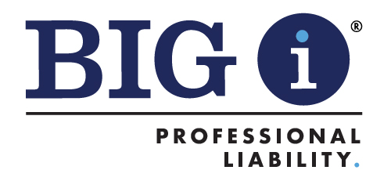

E&O Program Conference
Hilton Orlando Lake Buena Vista – Disney Springs® Area
Orlando, FL
May 19-21, 2024

Health & Safety Measures

The safety of our meeting attendees is paramount. We are taking the following precautions and adhering to any state, local and venue requirements.

Acknowledgement of Enhanced Safety and Health Measures:
Registration and attendance at, or participation in, the E&O Program Conference in person constitutes an agreement by the registrant to abide by IIABA’s and the host property's efforts to comply with any state, local and/or venue requirements and to engage in certain health-and-safety-beneficial conduct while attending the event as may be requested.

Guidelines and Precautions

General Information
- To the extent desired, attendees should bring their own personal protective equipment (e.g., masks and hand sanitizer) for their personal use.
- It’s mandatory to accept the meeting waiver located on the event registration site prior to attending the meeting.

General Hotel Cleanliness
- In an effort to enable safe travel, the Hilton Orlando Lake Buena Vista – Disney Springs® Area supports the American Hotel & Lodging Association’s Safe Stay Guidelines.

COVID-19 Response and Protocols
- If a guest begins to feel ill, he/she is strongly encouraged to seek testing for COVID-19 and remain isolated until the guest receives a negative test or can depart from the hotel facilities and return home or go to a medical facility.
- If a guest tests positive for COVID-19 and needs care, the guest is strongly encouraged to seek a medical facility.
- All attendees are asked to inform IIABA if they test positive for COVID-19 during or shortly after the conference.

Hospitals and urgent care if needed:

AdventHealth Celebration (hospital)
400 Celebration Place
Celebration, FL 34747
(407) 303-4000
(6.7 miles/12 minutes driving)

AdventHealth Centra Care Lake Buena Vista
12500 South Apopka Vineland Road
Orlando, FL 32836
(407) 934-2273
(1.1 miles/5 minutes driving)

Buena Vista Urgent Care
8200 World Center Drive
Orlando, FL 32821
(407) 465-1110
(2.6 miles/11 minutes driving)

Urgent Care 24/7 Orlando
2940 Mallory Circle, Suite 204-A
Celebration, FL 34747
(321) 209-8939
(6.5 miles/12 minutes driving)

CVS Minute Clinic
5308 W. Irlo Bronson Memorial Hwy
Kissimmee, FL 34746
(407) 390-9431
(4.7 miles/16 minutes driving)

