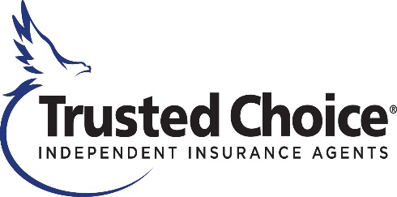

Big “I” Fall Leadership Conference
JW Marriott Indianapolis
Indianapolis, IN
September 3-8, 2024

Health & Safety Measures

The safety of our meeting attendees is paramount. We are taking the following precautions and adhering to any state, local and venue requirements.

Acknowledgement of Enhanced Safety and Health Measures:
Registration and attendance at, or participation in, the Big “I” Fall Leadership Conference in person constitutes an agreement by the registrant to abide by IIABA’s and the host property's efforts to comply with any state, local and/or venue requirements and to engage in certain health-and-safety-beneficial conduct while attending the event as may be requested.

Guidelines and Precautions

General Information
- To the extent desired, attendees should bring their own personal protective equipment (e.g., masks and hand sanitizer) for their personal use.
- It’s mandatory to accept the meeting waiver located on the event registration site prior to attending the meeting.

General Hotel Cleanliness
- In an effort to enable safe travel, the JW Marriott Indianapolis supports the American Hotel & Lodging Association’s Safe Stay Guidelines.

COVID-19 Response and Protocols
- If a guest begins to feel ill, he/she is strongly encouraged to seek testing for COVID-19 and remain isolated until the guest receives a negative test or can depart from the hotel facilities and return home or go to a medical facility.
- If a guest tests positive for COVID-19 and needs care, the guest is strongly encouraged to seek a medical facility.
- All attendees are asked to inform IIABA if they test positive for COVID-19 during or shortly after the conference.

Hospitals and urgent care if needed:

IU Health University Hospital
550 N. University Blvd.
Indianapolis, IN 46202
(317) 944-5000
(1.3 miles/6 minutes driving)

IU Health Methodist Hospital
1701 N. Senate Blvd.
Indianapolis, IN 46202
(317) 962-2000
(2.6 miles/8 minutes driving)

IU Health Urgent Care – Downtown Indianapolis
222 W. Michigan Street
Indianapolis, IN 46204
(317) 779-0303
(1.2 miles/5 minutes driving)

